*Support Vector Machine*

Image classification & Image Sementation , Object detection

& it also much use in field of biology,

digital character recognition

Decision boundary kaise humme alag alag angle or tarike se draw krskte but usmese best kaunsa hai

Yeah decide karne mai humme SVM help krta hai

Best Decision Boundary kaunsi hai vo find karne mai humme SVM help karta hai

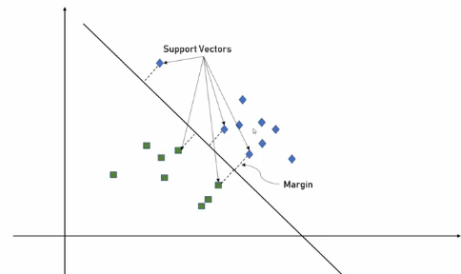

Margin ko humm bolte hai Support Vectors

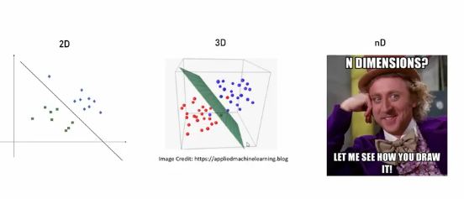

n-dimension plane ko hum calculate krte hai by Hyperplane

*Gamma & Regularization*

